**Supplementary Files**

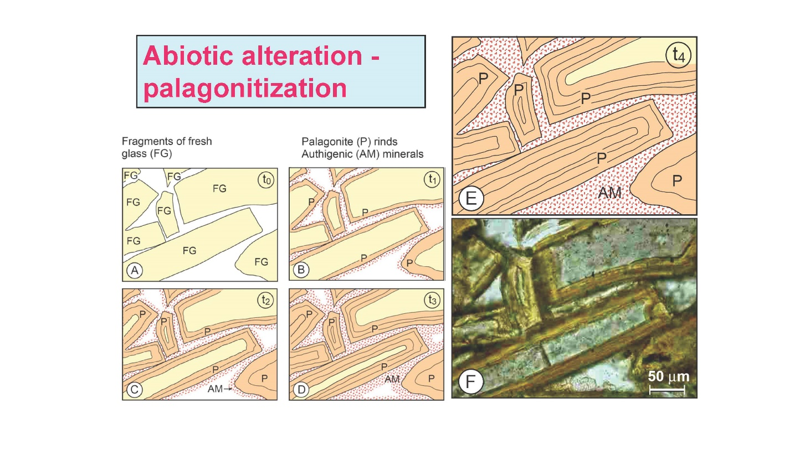

**Supplementary figure S1**

Various stages (t0 – t4) in the abiotic alteration process (palagonitization) from fresh glass (A), to progressively more transformation of the fresh glass to palagonite, simultaneously with authigenic mineral formation along the outer edges of the fragments (B through D). At the final stage t4 (E) the spaces between the fragments are filled with authigenic minerals, thus preventing fluid flow, and the alteration process slows down or stops. The final picture (F) shows a hyaloclastite sample from a subglacial deposit in Iceland, from which the alteration stages have been outlined.

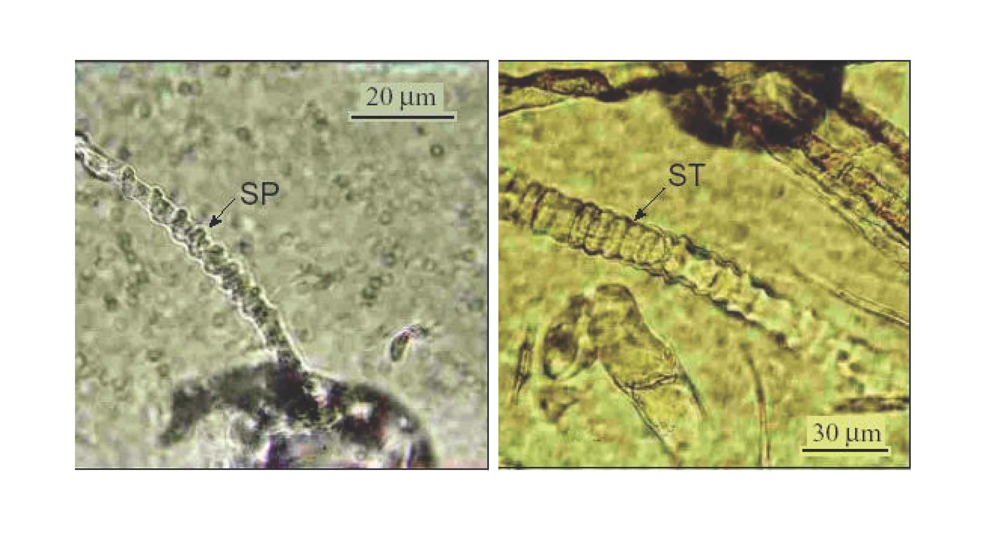

**Supplementary figure S2**

Tubular textures showing spiral development (left) and segmented example (right). Examples from glassy selvage of pillow lava from the Troodos Ophiolite Complex, Cyprus. Abbreviations: SP: spiral; FG: fresh glass; ST: segmented tube.

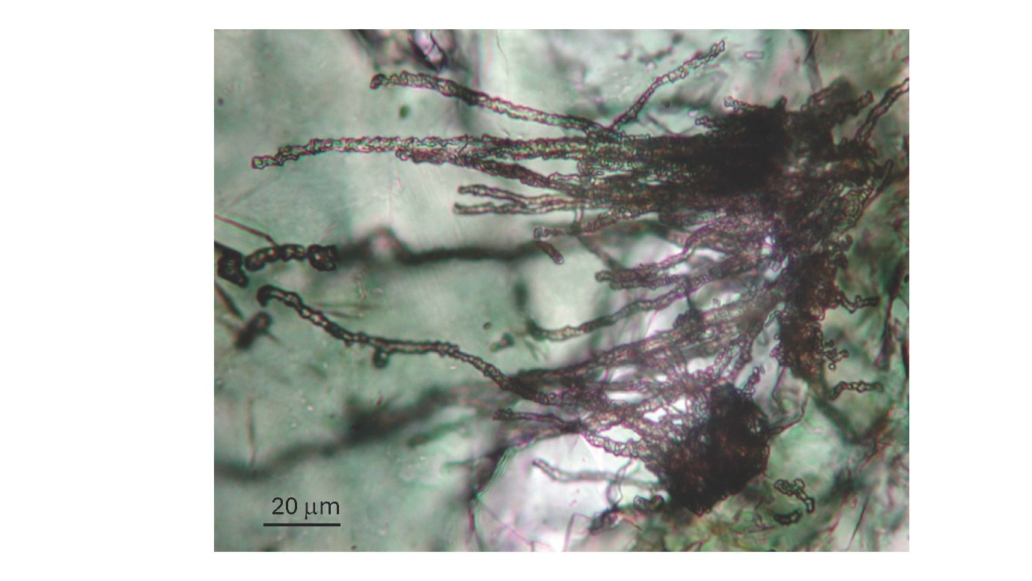

**Supplementary figure S3**

Tubular textures in pillow lava selvage from the 3343-3369 Ma Euro Basalt, Warrawoona Group. The MC-ICP-MS age (U-Pb) of the tubes has been dated to 2921 +/- 110 Ma (See Banerjee et al., 2007).

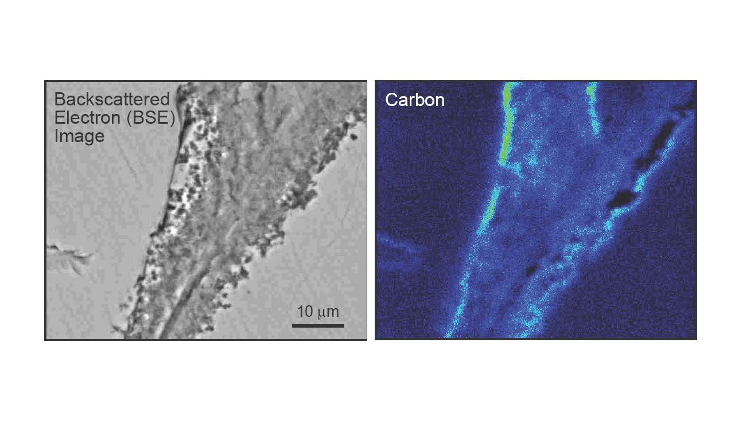

**Supplementary figure S4**

Back scatter electron image of granular bioalteration fronts on either side of a fracture. Accompanying X-ray map show enrichment of carbon (C) on both sides of the granular textural development. The example is from sample CYP-99-14A, Troodos ophiolite Complex.

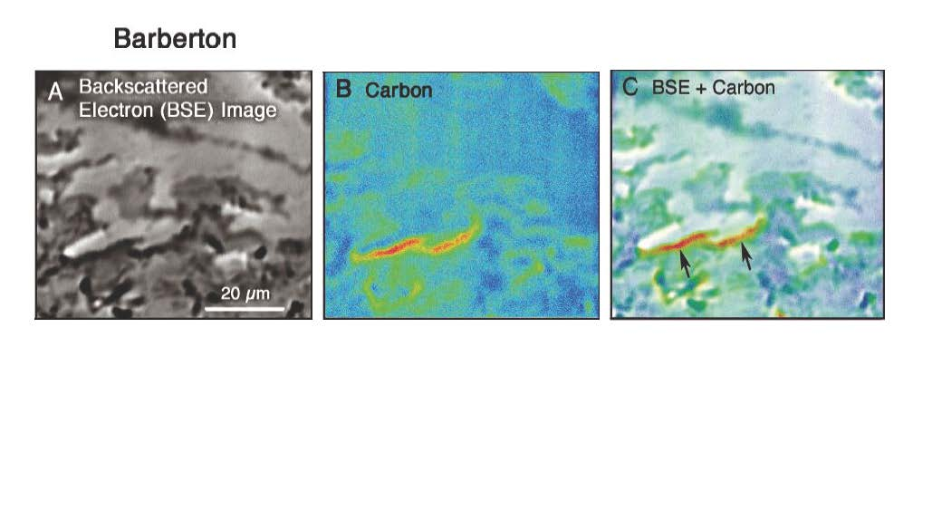

**Supplementary figure S5**

Backscatter electron image (A) of tubular texture in hyaloclastite from the Barberton

greenstone belt, and X-ray map (B) showing enrichment of carbon. Panel C shows the combined image of panels A and B, and the carbon enrichment is indicated by arrows. Modified from Furnes et al. (2008).

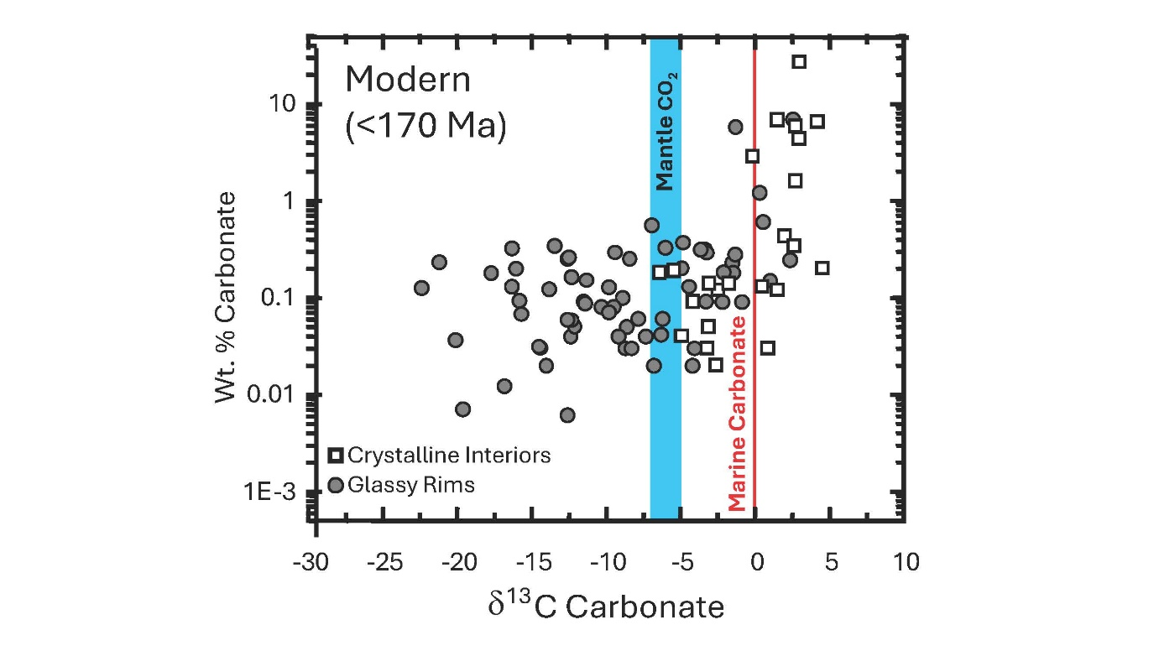

**Supplementary figure S6**

Relationships between δ13Ccarbonate and wt.% calcite for glassy and crystalline pillow lava samples from in-situ oceanic crust from the Costa Rica Rift, the Atlantic Ocean and the Lau Basin. Modified from Furnes et al. (2001a).

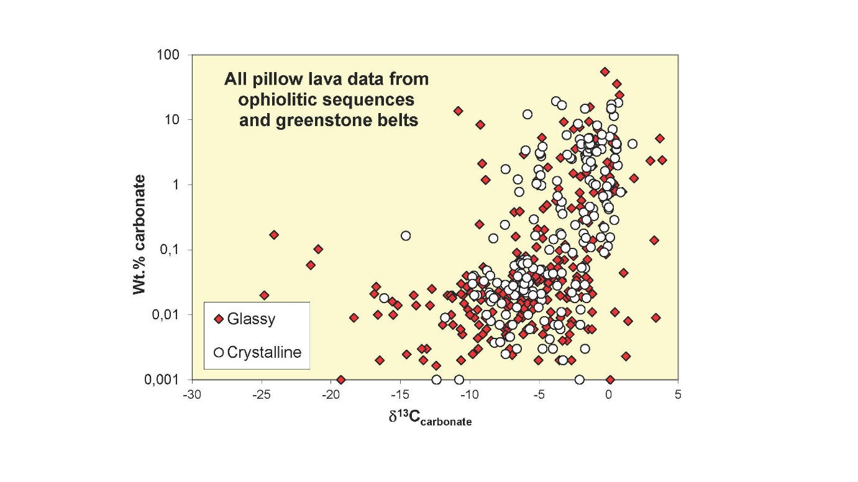

**Supplementary figure S7**

Relationships between δ13Ccarbonate and wt.% calcite for glassy and crystalline pillow lava samples from ophiolites and greenstone belts. The ophiolites include the following;: Solund-Stavfjord (Norway); Mirdita (Albania); Troodos (Cyprus); Kizildag (Turkey), Corsica ophiolites; Franciscan Complex (California); Jormua (Finland). The greenstone belts include the following: Barberton (South Africa); Pilbara Craton (Australia); Pechenha (Kola Peninsula, Russia); Isua (Greenland). Modified from Furnes et al. (2008).